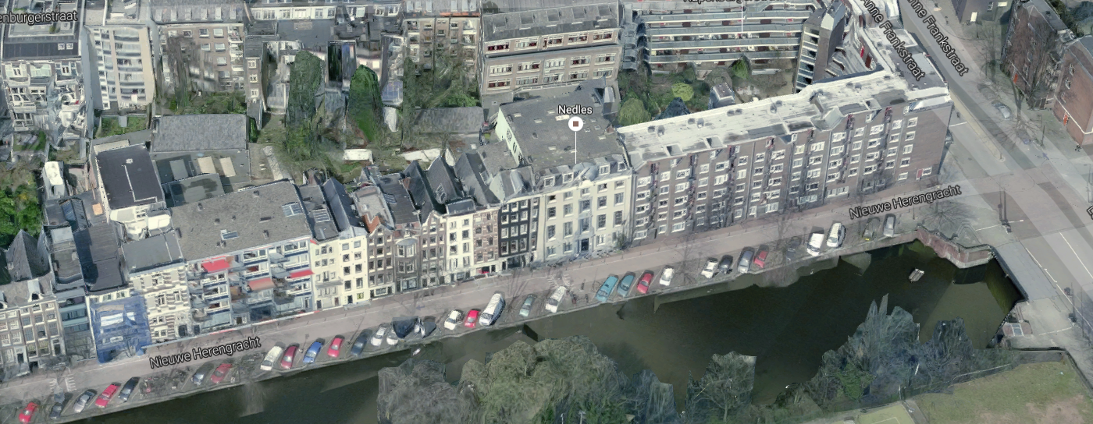

Familie Staal Amsterdam Nieuwe Herengracht 133 the house with the bow window September 2016

On the left two white houses, then a darker one with a pointed roof and then the house with the bow windows number 133